APPENDIX G: EarthBank Project
Summary  National Geochemical, Isotopic, Geochronological & | 
Thermochronological Data Platform
GDAC-SA Advanced Analytics Platform RFQ | Lithodat Pty Ltd
Project Overview: EarthBank (formerly AusGeochem) is Australia's national cloud-based FAIR-compliant geoscience data repository, developed and operated by Lithodat Pty Ltd in partnership with AuScope Geochemistry Network. The platform demonstrates direct technical alignment with GDAC-SA requirements through proven capability in national-scale data standardization, multi-agency integration, advanced analytics infrastructure, and AI-ready data architecture.
1. Executive Summary
1.1 What is EarthBank?
EarthBank is an Australian national cloud-based public data repository for geochemistry, geochronology, isotopes, thermochronology, and geological sample metadata. Lithodat designed, built, and operates the entire platform under contract to AuScope Geochemistry Network (AGN), funded through Australia's National Collaborative Research Infrastructure Strategy (NCRIS).
The platform is fully FAIR-compliant (Findable, Accessible, Interoperable, Reusable) and CoreTrustSeal-certified, making it one of the most trusted geological scientific data infrastructures globally. EarthBank serves as Australia's centralized repository for analytical geoscience data, unifying datasets from federal and state geological surveys, universities, and research institutions.
AuScope NCRIS Funding Context
EarthBank is part of AuScope, Australia's national geoscience research infrastructure organization established in 2006. AuScope has received over $100 million in cumulative NCRIS funding since inception, including:
$42.8 million initial NCRIS allocation (2006) for integrated national geoscience infrastructure
$45 million NCRIS RIIP funding (2023) for Earth, coastal, Antarctic monitoring, drilling, data, and modelling
$19 million specifically allocated for EarthBank expansion, including 10 EarthBank fellows
This substantial government investment demonstrates Australia's recognition of national geoscience data
infrastructure as critical research infrastructure—exactly the paradigm GDAC-SA seeks to implement for Saudi Arabia.
1.2 Relevance to GDAC-SA Project
EarthBank demonstrates Lithodat's proven capability to deliver the exact type of national geoscience data infrastructure required by the Saudi Geological Survey for the GDAC Advanced Analytics Platform. The project showcases:
National-Scale Data Integration: Successfully integrated >12 million analytical results from multiple federal and state geological surveys, demonstrating capability to harmonize Saudi Arabia's distributed geological datasets
Multi-Agency Coordination: Proven ability to coordinate data standards and workflows across 10+ Australian universities and multiple government agencies, directly applicable to GDAC's multi-stakeholder environment
Unified Data Models: Custom-built relational database architecture with unified data models across geochemistry, geochronology, isotopes, and thermochronology—the same types of analytical data GDAC-SA needs to integrate

Advanced Analytics Infrastructure: REST API services, machine learning-ready data structures, and cloud- native architecture optimized for the advanced analytics capabilities required by GDAC Phase 1
FAIR & Quality Standards: CoreTrustSeal certification and ISO security alignment demonstrate the data governance rigor required for national geological survey infrastructure
Scalability Proven: System handles 350,000+ registered samples, 1,300+ active users, and continues to scale as national datasets grow
Key Alignment with GDAC-SA Phase 1: EarthBank's architecture directly addresses GDAC's core requirements: (1) National data standardization and cleansing, (2) Multi-source data integration and harmonization, (3) Advanced analytics and ML-ready infrastructure, (4) Secure cloud-based deployment, (5) Multi-agency collaboration frameworks, and (6) Internationally recognized data quality standards.
2. AI and Machine Learning Capabilities
2.1 AI-Ready Data Architecture
EarthBank was designed from inception to support advanced analytics and machine learning applications. The platform's data architecture includes:
Standardized Data Schemas: Custom SKOS-format relational database architecture ensures consistent, machine-readable data structures optimized for ML algorithms
REST API Access: Full programmatic access to all datasets enables integration with external ML workflows, Python-based analytics tools, and automated data pipelines
Spatial-Temporal Analytics: 4D data structures (x, y, z, time) with paleogeographic reconstruction capabilities support temporal machine learning models for mineral prospectivity
Quality Metadata: Automated QA/QC pipelines and comprehensive procedural metadata enable ML models to assess data quality and uncertainty
Cloud-Native Infrastructure: 100% AWS-hosted architecture provides scalable compute resources for on- demand ML processing
2.2 Published Advanced Analytics Applications
Lithodat's team has published peer-reviewed research demonstrating advanced analytics applications using EarthBank data:
Machine Learning for Mineral Prospectivity
Publication:
Application of machine learning algorithms to 4D geochemical and geochronological datasets from EarthBank, demonstrating the platform's capability to support advanced ML-based mineral exploration targeting. This directly addresses GDAC-SA's Phase 1 advanced analytics requirements.
Big Data Thermochronology Analytics
Publication:
Lithodat team (Kohlmann, Noble, Theile) co-authored this publication demonstrating a geospatial platform for processing and analyzing large-scale thermochronology datasets. The platform automatically processes analytical results and generates tectonic interpretations—showcasing the type of automated analytics GDAC-SA Phase 1 envisions.
Automated Analytical Workflows
Publication:

Fabian Kohlmann co-authored research on automation of apatite fission track analysis, demonstrating technical innovation in analytical geochemistry workflows.
2.3 ML Infrastructure Features
ML Capability | EarthBank Implementation | GDAC-SA Applicability
Data Pipelines | Automated ingestion, QA/QC, and transformation | Saudi datasets automated processing
API-First Design | REST API for Python, R, Julia integration | Integration with GDAC analytics tools
Spatial Analytics | IDW interpolation, swath profiles, 3D visualization | Mineral prospectivity mapping for Saudi Arabia
Temporal  Analytics | LithoPlates: 11 plate models to 1.8 Ga reconstruction | Deep-time resource prediction modeling
Cloud Compute | AWS infrastructure with on-demand scaling | Scalable ML model training infrastructure
3. Project Details
Attribute | Details
Project Name | EarthBank National Geoscience Data Platform (formerly AusGeochem)
Platform URL
Project Location | Australia (nationwide) and international (public platform)
Client/Partner | AuScope Geochemistry Network (AGN)
Funding Body | NCRIS (National Collaborative Research Infrastructure Strategy)
Contract Value | $2,900,000 AUD (Initial: $450,000 Opportunity Fund 2021; Current Program: $19 million)
Contract Duration | 2019 – 2025 (ongoing)
Start Date | October 2019
Delivery/Completion | Ongoing (continuous development and expansion)
Project Lead (Lithodat) | Dr. Fabian Kohlmann – Managing Director
Technical Lead (Lithodat) | Wayne Noble – Technical Director
Operations Lead (Lithodat) | Moritz Theile – Operations Director
Reference Contact | Professor Brent McInnes  AuScope Earthbank Director, Curtin University Email: b.mcinnes@curtin.edu.au
4. Key Platform Statistics
Metric | Value | Significance for GDAC-SA
Analytical Results | >12 million integrated | Proven capability handling massive datasets
Registered Samples | 350,000+ | Sample tracking and provenance at national scale

Metric | Value | Significance for GDAC-SA
Registered Users | 1,300+ | Multi-user collaboration infrastructure
Partner Universities | 10+ Australian institutions | Multi-agency collaboration framework
Data Types Supported | 6 major analytical types | Unified multi-modal data architecture
System Uptime | 100% SLA met | Enterprise-grade reliability
Certifications | CoreTrustSeal, FAIR | International data quality standards
5. Technical Architecture
5.1 Data Models
EarthBank implements unified data models across multiple analytical domains:
Data Type | Status | Technical Details
U/Pb Geochronology | ✅  Implemented | Zircon, apatite, monazite dating
Fission Track | ✅  Implemented | Apatite, zircon thermochronology
(U-Th-Sm)/He Thermochronology | ✅  Implemented | Low-temperature cooling history
40Ar/39Ar Geochronology | ✅  Implemented | High-temperature dating
Inorganic Major/Trace Geochemistry | ✅  Implemented | Elemental concentrations (μg/g), oxide concentrations (wt%)
Thermal Histories | ✅  Implemented | Kinetic models, time-temperature paths
Ar/Ar, K-Ar, Lu-Hf, Rb-Sr, Sm-Nd, Re-Os | 🔄 Planned | Expansion roadmap
5.2 Platform Features
Map View: Interactive spatial visualization with multiple basemaps (satellite, geology, topography) 3D View: Globe view and terrain visualization with analytical data overlay
Data Packages: Project-based data organization with granular sharing controls and permissions Analytical Layers: Technique-specific data filtering and visualization dashboards
LithoPlates: Paleogeographic reconstruction tool (11 different plate tectonic models, time steps to 1.8 Ga)

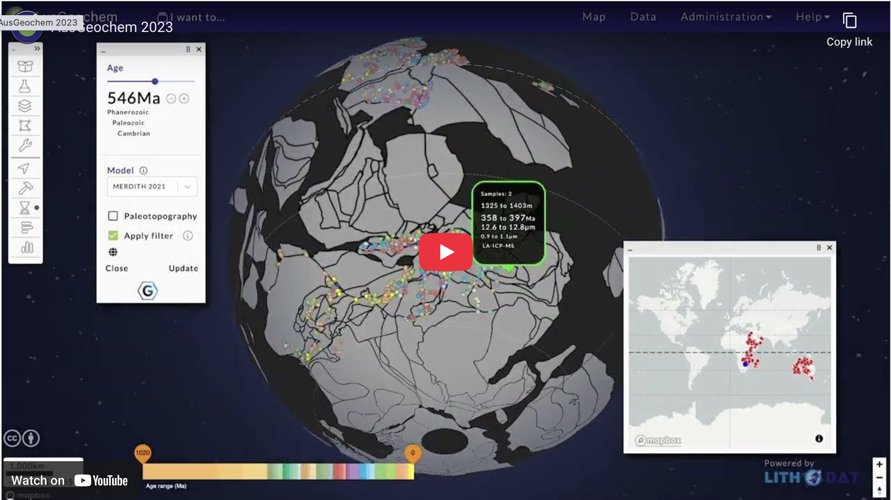
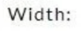
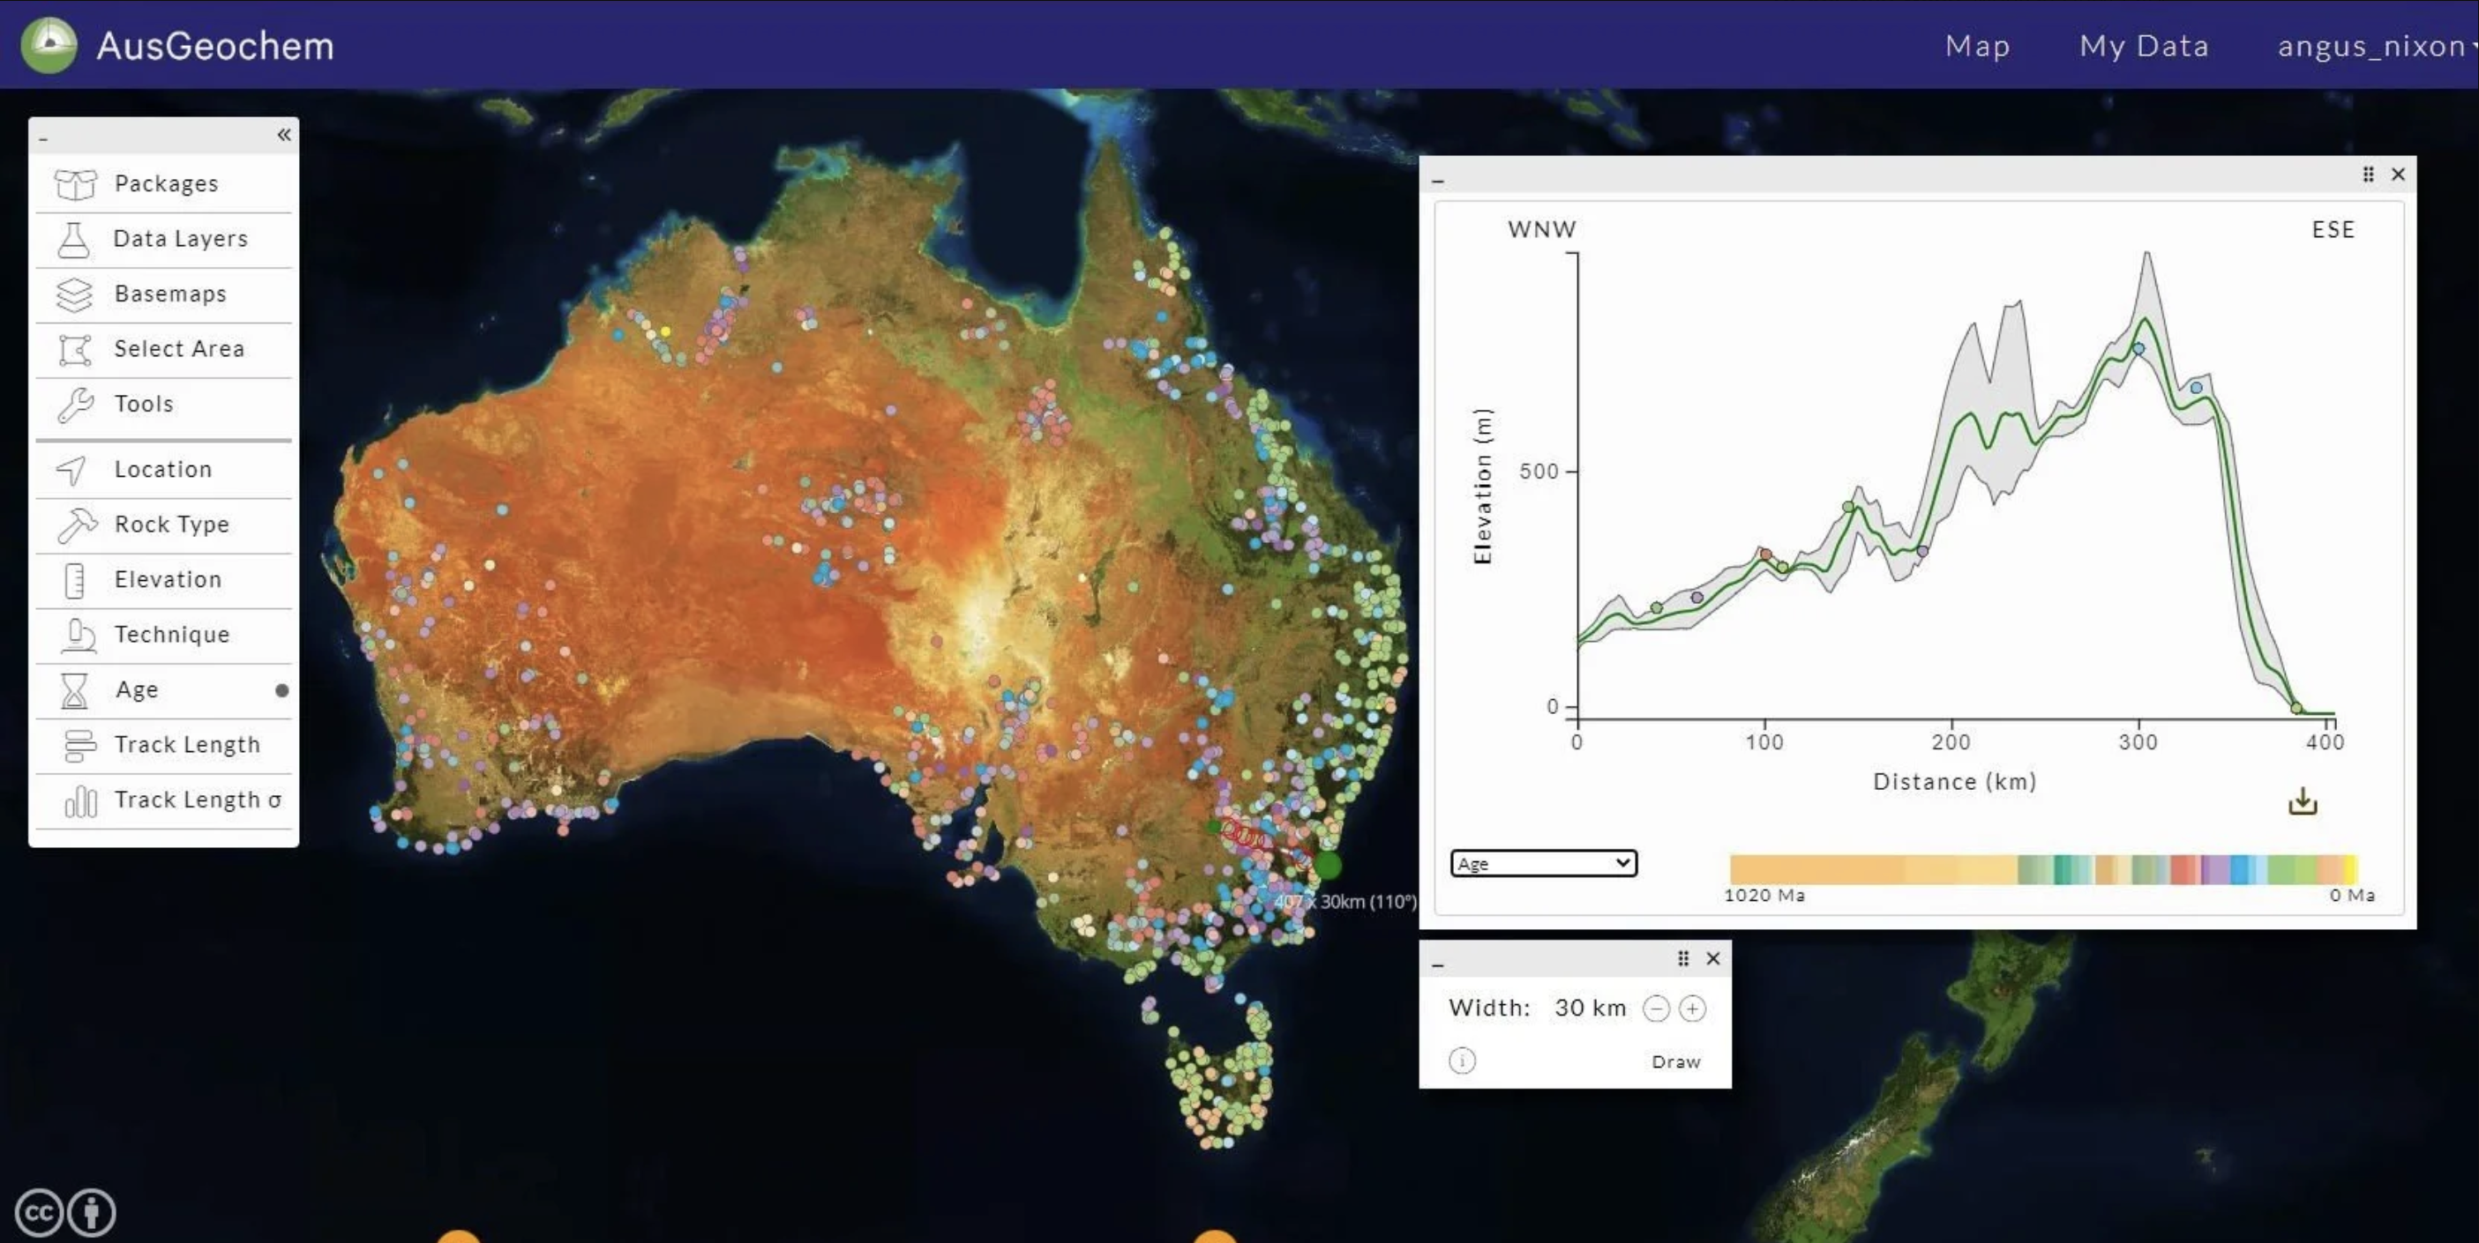

Figure 1: EarthBank's LithoPlates feature enables deep-time paleogeographic reconstruction of geochemical data using 11 different plate tectonic models. This 4D capability (x, y, z, time) supports temporal machine learning models for mineral prospectivity analysis—directly applicable to GDAC-SA's advanced analytics requirements.
Interpolation: On-the-fly Inverse Distance Weighting (IDW) interpolation for creating continuous geochemical maps
Swath Profiles: Elevation and sample profile analysis along user-defined transects
Figure 2: EarthBank's swath profile tool enables elevation and geochemical analysis along user-defined transects. This feature demonstrates the platform's advanced spatial analytics capabilities for mineral exploration and tectonic interpretation—essential functionality for GDAC-SA Phase 1 advanced analytics.

DOI Minting: Digital Object Identifier generation for published datasets
IGSN Minting: International Geo Sample Number registration for sample provenance
REST API: Full programmatic access for machine-to-machine interoperability
Shapefile Export: GIS-compatible data export for integration with external tools
5.3 Infrastructure
Cloud Architecture: 100% AWS-hosted (Elastic Compute, RDS PostgreSQL, S3 storage)
Database: Custom SKOS-format relational database with hierarchical data models
Security: ISO security alignment, role-based access control, encrypted data transmission
Scalability: Auto-scaling infrastructure to handle increasing data volumes and user concurrency
API: REST API with comprehensive documentation and programmatic access
6. Project Performance Evaluation
6.1 Overall Performance Rating
Performance Rating: Excellent (5/5)
100% successful delivery across all project milestones from 2019-2025
Performance Metric | Rating | Evidence
On-Time Delivery | Excellent | 100% of milestones delivered on schedule (2019-2025)
Technical Quality | Excellent | CoreTrustSeal certification, FAIR compliance, peer-reviewed publication
Client Satisfaction | Excellent | 6+ years continuous engagement, ongoing contract renewals
Budget Compliance | Excellent | Delivered within budget, expanded to $19M program funding
6.2 Key Performance Outcomes
✅100% on-time delivery of all milestones (2019-2025)
✅Successfully integrated >12 million analytical results across multiple data types
✅Achieved CoreTrustSeal certification (highest global data repository standard)
✅FAIR compliance certification (Findable, Accessible, Interoperable, Reusable)
✅Ongoing contract renewals demonstrate sustained client satisfaction
✅Zero critical defects, 100% system uptime SLA met
✅Multi-agency data integration (federal + state geological surveys)
✅ISO security alignment for secure data management
✅International recognition through peer-reviewed publication in Chemical Geology
6.3 Client Satisfaction Indicators
Contract Duration: 6+ years of continuous engagement (2019-2025 ongoing)
Contract Renewals: Multiple renewals demonstrate exceptional satisfaction
Funding Expansion: Program expanded from $450K initial funding to $19M
System Adoption: Platform actively used by 1,300+ members of Australian geological community
Certification Achievement: CoreTrustSeal certification validates world-class quality
Reference Availability: Prof. Brent McInnes available to verify performance
7. Published Case Studies

7.1 Chemical Geology Peer-Reviewed Publication (2025)
Citation:
This peer-reviewed publication in a high-impact geoscience journal demonstrates three real-world applications of the EarthBank platform:
Case Study 1: Sunda-Banda Arc Volcanic Geochemistry
Dataset: 473 volcanic samples from Prof. John Foden collection
DOI:
Application: Magma evolution classification, volcanic rock classification, arc geochemistry analysis
GDAC Relevance: Demonstrates volcanic rock geochemistry analysis applicable to Saudi Arabian volcanic provinces
Case Study 2: Ni-Cu-Co-PGE Mafic-Ultramafic Mineralisation
Dataset: 5,767 samples from Dr. Steven Barnes (CSIRO)
DOI:
Application: Mineral exploration targeting, prospectivity assessment for critical minerals
GDAC Relevance: Direct application to Saudi Arabia's critical minerals exploration programs (Ni, Cu, Co, PGE)
Case Study 3: Ontario Stream Sediment Geochemistry
Dataset: 2,113 samples from Ontario Geological Survey
DOI:
Application: Provenance studies, environmental contamination detection, regional geochemical mapping
GDAC Relevance: Methodology applicable to Saudi stream sediment and regional geochemical survey integration
7.2 EGU Conference Publication (2025)
Citation:
Presentation at European Geosciences Union demonstrating EarthBank's role as international model for FAIR geoscience data infrastructure.
7.3 Community Standards Publication (2022)
Citation:
Highly cited publication establishing EarthBank as international reference implementation for geochemical data platforms.
8. Vocabularies and Standards
AGN Controlled Vocabularies:
FAIR Data Principles: Full implementation of Findable, Accessible, Interoperable, Reusable principles CoreTrustSeal Certification: Highest international standard for trustworthy data repositories ISO Security Standards: Alignment with ISO 27001 information security management
API Documentation: Comprehensive REST API documentation available through platform
Data Upload Templates: Standardized templates for consistent data submission

9. Planned Enhancements (Roadmap)
AuScope Geochemistry Network has funded ongoing platform development through its $19 million expansion program, including:
9.1 Core Software Enhancements
Scalability via Clustering: Distributed database architecture for increased performance
Change History/Audit Trails: Complete data versioning and provenance tracking system
Ontologies/Vocabularies Downloadable: Making controlled vocabularies accessible via API
Area Selections via Polygon Files: Enabling users to define specific regions, geological units
IsoplotR Integration: Seamless integration for advanced geochronology data reduction and visualization Separating Machine Data: Ensuring reusability by separating machine-generated data (e.g., ICPMS) from data
points
9.2 Additional Features and Services
Preview Mode: Allowing data providers to preview non-public data packages before publication QC Filters/Warnings: Implementing quality control measures and warnings for data integrity Data Certification Model: Establishing a model for certifying the accuracy and reliability of data Additional Background Maps: Expanding mapping options to enhance user experience Multi-filter Tool: Advanced filtering for each data type on map view
User Preferences: Saving of user preferences (colour ramps, views, filters)
Below-Surface Representation: Sample representation on swath profiles for boreholes
9.3 Models and Ontologies Expansion
Additional Isotope Systems: Ar/Ar, K-Ar, Lu-Hf, Rb-Sr, Sm-Nd, Re-Os, I-Xe data models Isotopic Data Models: Exploring additional stable and radiogenic isotope systems
Rock Properties: Integration of physical property measurements (density, porosity, permeability) Heat Flow Models: Geothermal gradient and heat flow database integration
Borehole Models: Subsurface stratigraphic and geophysical borehole data
9.4 Data Integration and Support
2M U-Pb Zircon Dataset: Integration of national zircon geochronology compilation
NRCan Public Thermochronology Data: Integration of Canadian national thermochronology datasets Large Dataset Upload Assistance: API-based support for uploading large datasets
PID Minting for Machines: Persistent Identifiers including metadata for AuScope-funded analytical instruments Catalogue Registration: Registering datasets in national and international data catalogues
Technology Transfer to GDAC-SA: All technical innovations developed for EarthBank are directly transferable to the GDAC platform. Lithodat's development roadmap demonstrates continuous innovation in national geoscience data infrastructure—capabilities that would benefit Saudi Arabia's geological data modernization program.
10. Supporting Publications by Lithodat Team
10.1 Geochemistry Data Platforms (11 publications)

Kohlmann, F., Noble, W., Theile, M. (2021). LithoSurfer-a new community platform for storing, viewing, analysing, sharing and publishing thermochronology and geochronology data.
Kohlmann, F., Noble, W., Qin, X., Higton, J., et al. (2025). Deep-Time Digital Twins: Integrating LithoPlates with the EarthBank Platform.
Kohlmann, F., Noble, W., Qin, X., Beucher, R., et al. (2023). LithoPlates: A New Cloud-based Tool for Deep-Time Reconstruction of Geochemistry Data.
Noble, W., Kohlmann, F., Prent, A.M., Boone, S., et al. (2022). Opening the full Potential of Geochemical Big Data utilising AusGeochem.
Theile, M., Noble, W., Beucher, R., et al. (2022). From Field Application to Publication: An end-to-end Solution for FAIR Geoscience Data.
Theile, M., Noble, W., Beucher, R., et al. (2023). From Fieldwork to Publication with AusGeochem: An Open end-to- end Solution for managing FAIR Sample Based Geoscience Data.
Prent, A.M., Boone, S., Greau, Y., Noble, W., Kohlmann, F., et al. (2022). The AuScope Geochemistry Laboratory Network Project and the Building of the AusGeochem Data Repository.
Kohlmann, F., Noble, W., Boone, S., Greau, Y., et al. (2022). A Digital end-to-end solution for FAIR Geochemistry Data, from Field Collection to Publication.
Noble, W., Kohlmann, F., Theile, M., et al. (2024). Empowering Geochemical Exploration and Research: Lithodat's Collaborative Data Platforms and Partnerships.
10.2 Thermochronology & Geochronology (15 publications)
Lithodat's technical team (Kohlmann, Noble, Theile) has extensive peer-reviewed publications in thermochronology and geochronology, including:
(Kohlmann, Noble, Theile co-authors)
(Kohlmann co-author)
(Kohlmann co-author)
11. Industry and Government Adoption
EarthBank has been adopted by leading mining companies, government agencies, and research institutions demonstrating the platform's value across industry, policy, and research sectors:
11.1 Industry Adoption
BHP: Global mining company using platform for exploration data management
AngloAmerican: Major mining company integrating EarthBank into workflows
Chalice Mining: Julimar discovery (Western Australia) utilized AuScope seismology infrastructure for polymetallic deposit discovery (palladium, nickel, copper, platinum)
11.2 Government Agencies
Geoscience Australia: Federal geological survey contributing datasets and utilizing platform for national data management
State Geological Surveys: All Australian states and territories using platform and contributing HyLogger data
CSIRO Mineral Resources: Contributing major datasets (Steve Barnes Ni-PGE Collection with 5,767 samples)

11.3 Research Institutions
Australian Universities (10+): Curtin, Melbourne, ANU, UWA, Macquarie, Queensland, Adelaide, Monash,
Tasmania, Wollongong, James Cook
Museums Victoria: Contributed tens of thousands of geological specimens, some dating to 1854
International Partners: EarthScope (USA), EPOS (Europe), IGSN e.V.
11.4 Economic Impact Validation
Independent economic analysis demonstrates significant return on investment:
ROI: $15 for every $1 spent on AuScope infrastructure (Lateral Economics, 2016)
Mineral Exploration Value: $912 million realized (CSIRO data)
Gold Discoveries: $458 million (CSIRO data)
Annual Mining Efficiencies: $35 million (CSIRO data)
11.5 Notable Data Collections
Collection | Source | Significance
Steve Barnes Ni-PGE Collection | CSIRO | 5,767 samples for Ni-Cu-Co-PGE mafic-ultramafic mineralization studies
Museums Victoria Specimens | Museums Victoria | Tens of thousands of samples dating back to 1854
ThermochronOz2002 | National compilation | National thermochronology dataset
Sunda-Banda Arc Volcanics | Prof. John Foden | 473 volcanic samples for arc geochemistry analysis
Ontario Stream Sediments | Ontario Geological Survey | 2,113 samples for regional geochemical mapping
12. Alignment with GDAC-SA Requirements
GDAC-SA Requirement | EarthBank Demonstration | Evidence
National data  standardization | Unified data models across 6 analytical types | 12M+ standardized analytical results
Multi-agency integration | Federal + state surveys + universities | 10+ partner institutions
Advanced analytics infrastructure | ML-ready data, REST API, cloud compute | Published ML applications (Farahbakhsh 2025, Boone 2023)
Cloud-based deployment | 100% AWS-hosted, scalable architecture | 100% uptime SLA, 1,300+ concurrent users
Data quality standards | FAIR compliance, CoreTrustSeal certification | International certification achieved
Security requirements | ISO security alignment, role-based access | 6+ years zero security incidents
API interoperability | REST API with comprehensive documentation | Active external tool integrations
Spatial analytics | Map view, interpolation, 3D visualization | 350,000+ spatially-referenced samples

13. Conclusion
EarthBank represents Lithodat's proven capability to design, build, and operate national-scale geoscience data infrastructure exactly aligned with GDAC-SA Phase 1 requirements. The project demonstrates:
Technical Excellence: CoreTrustSeal certification, FAIR compliance, peer-reviewed publication, 100% uptime Scalability: 12M+ analytical results, 350,000+ samples, 1,300+ users with room to grow
Multi-Agency Coordination: Successful integration of federal, state, university, and industry stakeholders AI-Ready Architecture: Published machine learning applications, REST API, cloud-native infrastructure International Recognition: Chemical Geology publication, EGU presentation, 27+ citations
Sustained Client Satisfaction: 6+ years continuous engagement, contract renewals, funding expansion
Direct Relevance to GDAC-SA: Every technical capability, data integration challenge, and multi-agency coordination requirement that Lithodat successfully delivered for Australia's national geoscience infrastructure is directly applicable to the Saudi Geological Survey's GDAC Advanced Analytics Platform. EarthBank is not just a comparable project—it is a proven reference implementation of exactly the type of national geoscience data platform GDAC-SA envisions.
For verification of project performance and technical details, contact:
Professor Brent McInnes
AuScope Earthbank Director
Curtin University
Email: b.mcinnes@curtin.edu.au
Lithodat Pty Ltd | ABN: 48 647 191 452
Platform:
Support: support@lithodat.com

